Tips and Tools

Front page
The following pages have been designed to provide you with information to help manage your breathing condition. They aim to provide you and your whanua tips and tools to cope with the changes that may have occurred.

Each page will include some tips for making every day activities easier and more enjoyable.

There are 12 different topics below, just click on the title and it will show you some more information. You can view the pages in any order and as many times as you wish.

- How do I get started with exercise?

Welcome to mPR

Before starting a new exercise programme it is good to go over a few points to keep you safe while exercising.
Always start your exercise with a gentle warm up. This prepares your body for exercise and ensures a gradual increase in breathing rate and heart rate. Start your walk a little bit slower and increase the pace after a few minutes. Also, the last few minutes of exercise should include a gradual cool down.

Ideally, we should exercise on five days of the week. When exercising, it is good to be a little breathless. You should aim for level 3 to 4, moderate intensity on the BORG scale. Or a pace which you can walk and talk. Your exercises should take about 30 minutes to complete. If you find it too hard to do them all at once, it is ok to break the exercises up into chunks. Just try and complete all the exercises in the day.

If you have signs of an infection such as a fever, increased phlegm, or increased breathlessness it is a good idea to have a rest day. Do not exercise if you have chest pain or dizziness or are light headed.

Video

https://youtu.be/jjLds4yRYHE

Links

https://www.health.govt.nz/your-health/healthy-living/food-activity-and-sleep/physical-activity/being-active-everyone-every-age/starting-physical-activity-when-you-havent-been-active

- What can I do when I feel breathless?

Being short of breath can sometimes be distressing. It is good to have some tools to help you to get your breathing back under control. Try these tools when you are feeling well, so they will be more helpful when you might need them.

Positioning – stop and either lean forward on a table, or sit and lean forward on your knees.

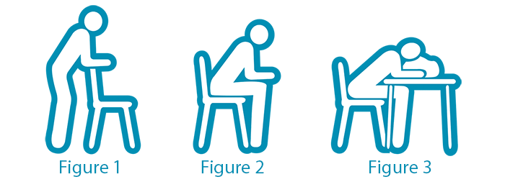
Breathing techniques - breathe in through your nose and out through pursed lips like you are blowing out a candle. Try to make your breath out longer than you breath in. Place one hand on your tummy and try to feel your tummy move out when you breathe in.
Fans – a hand held fan can be helpful to reduce the feeling of breathlessness. Hold it 15 cm from your face and point the air to your top lip.
Breathing around the rectangle – Find a rectangle in the room and focus your breathing as you move your eyes around the rectangle. Breathe in on the short side and breathe out along the long side. Keep moving your eyes around the rectangle as you slow down your breathing.
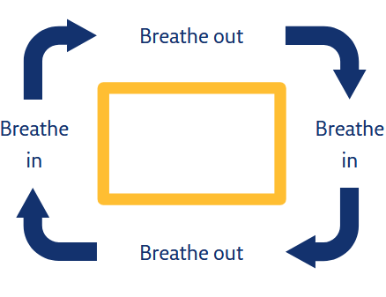

Video

https://youtu.be/F4Q0QFwphA0

Links
Asthma and respiratory foundation website
https://www.asthmafoundation.org.nz/

https://pulmonaryrehab.com.au/importance-of-education/education-topics/managing-breathlessness/

- How can I stop running out of energy?

Energy conservation is about adapting the way we do activities to ensure we have some strength and energy left for the activities which are meaningful to us.

Prioritise – identify which is the most important task for the day and complete this first. Work out which tasks can be delegated to others to help out and which chores can wait.

Plan ahead – write a list of jobs for the week and spread the heavy/hard jobs over several days. Try and alternate hard and easy jobs. Do the hard jobs at the time of the day you have the most energy.

Pace yourself – Try not to rush and give yourself plenty of time to do activities. It is ok to break up chores with a rest. Stop half way through the lawns or vacuuming to allow yourself to catch your breath and then carry on. You will feel much better when you have finished.

Position and posture – Consider putting a chair in the bathroom so you can sit and catch your breath after the shower. You can use this for grooming and brushing your teeth to save energy.

Video
https://youtu.be/hwG2GkRAVWU

Links
Relaxation - Tarias

- How can I become more active?

Becoming more active

Our bodies are designed for moving and do not like us to sit for long periods of time.
Being physically active has many health benefits. It can reduce how breathless you feel and make activities of daily living easier.

Try to make sure you limit sitting time to no more than 45 minutes in one session.
Step counters are a useful way of reminding us to keep moving. They monitor how many steps we take each day. Studies have shown people with lung conditions should be taking more than 4,500 steps.

Below are some tips to help increase your daily step count and keep you physically active.
- When watching TV, stand up and march through the commercial breaks.
- After each chapter of your book, do five sit to stand exercises or walk down the hallway?
- Put the washing away one room at a time.

Video

https://youtu.be/pDTL5JCZzVI

Links

https://www.health.govt.nz/your-health/healthy-living/food-activity-and-sleep/physical-activity/sit-less-move-more

https://sportauckland.org.nz

https://www.health.govt.nz/your-health/healthy-living/food-activity-and-sleep/physical-activity/how-much-activity-recommended

- What can I do to keep myself well?

What does wellness mean to you?
This can be different for everyone. In general terms this may mean we are sleeping well, eating well and feeling well.

Here are a few tips for helping you to stay well

- Exercise! Aim to complete your exercise programme five days per week. Exercise is good for circulation, immunity, breathing and mood.
- Hand hygiene – Washing your hands is one of the most important ways of preventing infections.
- Take your medications every day – keep a watch for when your medications are getting low and order a new script before you run out. It can be a good idea to speak with your doctor about having some antibiotics at home to start with first signs of an infection.
- Monitor your symptoms and have an action plan – Check your signs & symptoms each day. This means looking at the mucus you are clearing, checking for any changes in amount, colour or stickiness. Note any changes in your breathing or cough which might be early signs of an infection. Make an action plan with your GP so you know what to do when feeling unwell.
- Eating well – Good food choices help to keep our energy levels stable and our body functioning well. Eat a colourful diet with lots of fruit and vegetables and keep well hydrated.
- Healthy sleep - A good night’s sleep is an important part of staying well. There are many things that can be done to help to get a good nights sleep -
- Flu vaccinations – The flu vaccination is recommended yearly. Check with your doctor about other vaccinations which might be good for you.
- If feeling unwell – See your doctor early, stay home and rest

Video
https://youtu.be/8foPoR1fJr8

Links
www.asthmafoundation.org.nz

- What is self care?

Self care is any activity which improves your wellbeing, both physically and mentally.
Living with a breathing condition means changes in your body that can affect your mood. For some this may include; being breathless, weight loss, low energy, poor sleep and needing to be dependent on others.
Self care is about looking after yourself to help you to manage your symptoms and be able to do the things you want to do.

Self care is about creating a “B A C E”.
Try and do one activity each day from each of the boxes below.

Body Care – This involves taking the time to look after your physical wellbeing.
Getting a good nights sleep, eating well, practising relaxation.

Achievement – Doing something which gives a sense of achievement. This might be a crossword Puzzle, or a chore such as hanging out the washing or weeding the
garden

Connection – activities which make us feel connected to people, nature, animals of our
Beliefs. Spend time with family, talking on the phone, linking in with a group.

Enjoyment – Doing something which makes us smile and brings joy and happiness.
Read a book, knitting, music, going for a walk

Video
Self Care - BACE.mov
Control:can't control.mov

Links
https://www.doc.govt.nz/parks-and-recreation/things-to-do/
https://www.mentalhealth.org.nz/home/ways-to-wellbeing/
https://www.healthnavigator.org.nz/healthy-living/l/looking-after-yourself/

- How can I get a good night’s sleep?

A good night sleep is an important step in keeping well.
There are many things that can ne done to improve our sleep. Here are a few suggestions of steps that can help and some which we should avoid

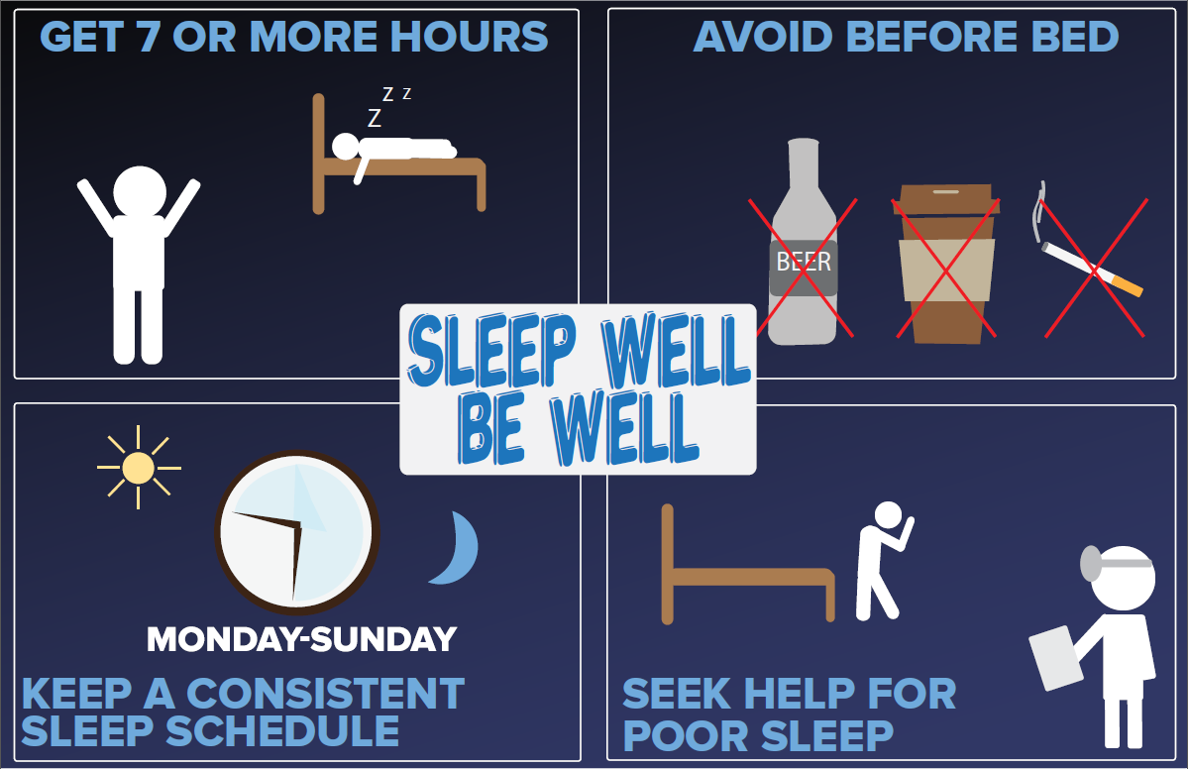

Video
https://www.youtube.com/watch?v=y6ZFzNxirIo

Links
https://www.healthinfo.org.nz/patientinfo/46895.pdf
https://www.healthnavigator.org.nz/media/3766/sleep-healthy-sleep-hygiene-poster.pdf

- What are the best foods to be eating?

Healthy eating is important for everyone. Here are some tips to help maintain healthy eating when you have a breathing condition.
- Eat a wide variety of nutritious foods from the four food groups
Meat, fish, eggs, poultry
Milk and milk products
Grain foods
Fruit and vegetables

- Try to eat the rainbow … colourful fruits and vegetables which are packed with vitamins, minerals and fibre. Frozen options can be just as good as fresh.
- Keep hydrated … if you struggle to drink water, add some lemon slices or try herbal tea.
- If you feeling tired or breathless … try to eat softer foods that do not require as much chewing, such as mashed potato. Have smaller more frequent meals ( 5 or 6 snacks per day).
- Prepare larger meals and freeze portions for the days you do not feel like cooking
- Have nutritious snacks ready such as yogurt, dried fruit, cheese and crackers, milk drinks, smoothies


Links;

https://www.health.govt.nz/your-health/healthy-living/food-activity-and-sleep/healthy-eating?mega=Your%20health&title=Healthy%20eating

www.healthinfo.org.nz

- How can I clear the extra phlegm?

It is normal to have mucus in our airways and this has an important job of keeping our airways clean and clear.
In some cases, the lungs start to make a lot more mucus and this can become troublesome.
It is best to try and clear this mucus everyday to avoid infections and to be to breathe easier.
Here are some useful tips to help you to clear the excess phlegm.

- Keep hydrated – drinking plenty of water helps to keep the mucus thin, so it is easier to clear. Aim for 6 – 8 glasses of water per day, and more if you are exercising.
- Exercise! – Doing your exercise programme is a great way of helping to clear mucus. When you exercise you take larger breaths which helps to move the mucus.
- Breathing exercises – one of the best breathing exercises to clear secretions is called the active cycle of breathing technique or ACBT. To learn how to do this breathing exercise, watch the short video clip.

- Steam – If the mucus is thick and sticky and hard to clear, steam can help. Either a warm shower or put some hot water in a bowl and wave the steam over your face.

Video
www.youtube.com/watch?v=XvorhwGZGm8

Links

- Continence

Why do you need to know about incontinence?

Incontinence and other complaints of a weak pelvic floor are common for many people who have a chronic lung condition, such as COPD.

What is the pelvic floor?
It is a layer of muscle which holds up and supports the organs in the
pelvis including the bladder, bowel and Uterus (woman) or
prostate (men).

When the muscles contract they help to control the function of
the bladder and bowels. Coughing and sneezing can put extra
pressure of these muscles. The pelvic floor muscles are also important
for good posture.

How to do pelvic floor exercises

- Sit or lie comfortably and try to relax the muscles in your thighs, buttocks and abdomen.
- Tighten (and then relax) the muscles around your back passage as if you are trying to stop wind. Practice this movement until you are able to exercise these muscles correctly.
When you are passing urine, try to stop the flow mid stream and then re-start. This should only be performed occasionally as can interfere with normal bladder emptying

Good Bladder and Bowel Habits

- Try to drink six to eight cups of fluid a day (unless advised not to by your doctor).
- Limit the amount of caffeine (tea, coffee) and alcohol as these drinks irritate the bladder.
- Try to go to the toilet only when your bladder is full and you need to go.
- Take your time when urinating so you empty your bladder completely.
- Keep your bowels regular and avoid constipation.
- Do not strain when using your bowels.
- Keep up your pelvic floor exercise to keep your muscles strong.

Video
https://youtu.be/_OUbw8nuSeY

Links
https://www.continence.org.au/
http://www.pelvicfloorfirst.org.au/

- How can I give up smoking?

Congratulations on deciding to stop smoking.
Here are some tips that can help you along the way.
- Set a quit date
- Write a list of the reasons you want to quit
- Be aware of your triggers – and how to avoid them
- Patches, gum or lozenges can help
- What to do when you have cravings?

Drinkwater
Do something else
Take a deep breath
Delay

Quitline 0800 778 778
Txt2Quit – register at www.quit.org.nz

https://www.health.govt.nz/your-health/healthy-living/addictions/smoking/stop-smoking

- What has happened to my lungs?
Space holder …
Just COPD for now???
Lung modelling ….
Anatomy and physiology ….

